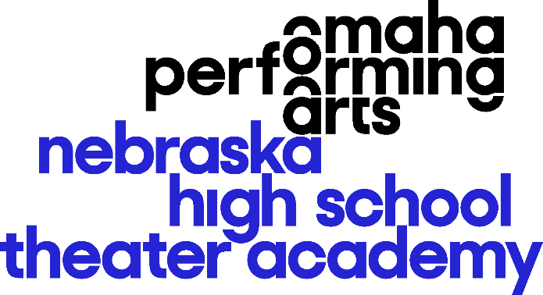

[Name of School] is proud to participate in Omaha Performing Arts’ Nebraska High School Theater Academy!

Culminating in a Tony Awards® inspired showcase, the program celebrates and supports theater education in Nebraska high schools and middle schools!

Participants can enjoy FREE Broadway master classes, workshops, professional feedback on school shows, ticket discounts, performance and audition experiences, awards, backstage learning, a chance to compete at nationals, and more.

Join us Thursday, June 13, 2024 for an evening of outstanding student performances with awards for top performers, excellence behind-the-scenes, and more at the eleventh annual NHSTA Showcase at the Orpheum Theater! For tickets, visit TicketOmaha.com or call 402.345.0606.

Visit NebraskaHSTA.org for more information!

Like us on Facebook at Facebook.com/NebraskaHSTA.OPA and follow us on Twitter and Instagram @NebraskaHSTA.

